HR Manager Job Description Template
HR Manager Job Description can be used on any job boards to find the best Human Resource Manager for your company. You can use this template that contains important skill sets and core responsibilities of your HR Manager.

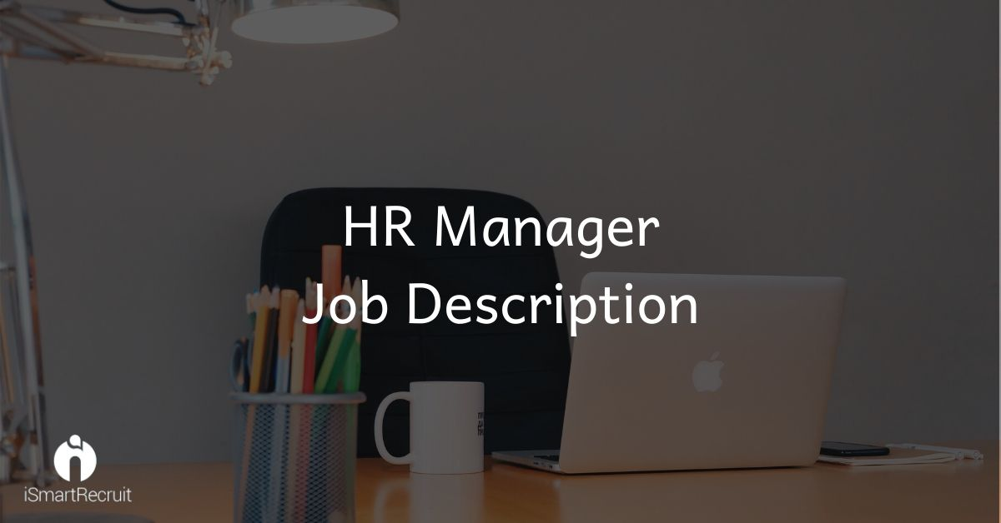
HR Manager Job Profile
HR Manager is the employee who is going to choose all of your future employees. This profile selection will decide what kind of employees you are going to get and what contribution they can put into pushing your company towards success.

HR Manager Job Description
We are looking for an enthusiastic HR Manager who can bring a lot of potential and responsible employees for our company that can help us to grow. HR Manager is the key person for any organization as he is going to decide the best candidates for the future of the company.
Core Responsibilities of HR Manager
- Building new HR Strategies for the benefit of the company.
- To build an easy-bridge between the employees and the Core Management to create a strong employer brand
- Conducting the recruitment process and screen the candidates
- Creating a positive work culture for the employees.
- Nurture the company rituals and strategize to adopt new and innovative ideas to make the company worth working for.
- Establish the HR Policies and resolve the ground-level employees problems
- Manage the current business plans and make the people follow them.

Requirements
- Proven working experience as HR manager or Recruiting Coordinator
- People-oriented and results-driven strategies
- Demonstrable experience with human resources metrics
- Knowledge of HR Technology
- Ability to manage the candidate database
- Ability to build strategy along with the leadership skills
- Excellent active listening, negotiation and presentation skills
- Proficiency to build and manage mutual relationships at all levels of the company
- In-depth knowledge of HR best practices and new HR Technology
- Bachelor Degree in Human Resources or related field
Are you looking for an HR Manager?
Promote your HR Manager job advertisement to 15+ free job boards and social media with just one click. Schedule a free personalized demo and start to post your job-ad today.

